**Case 7 Report: "The Upper Big Branch Mine Disaster "**

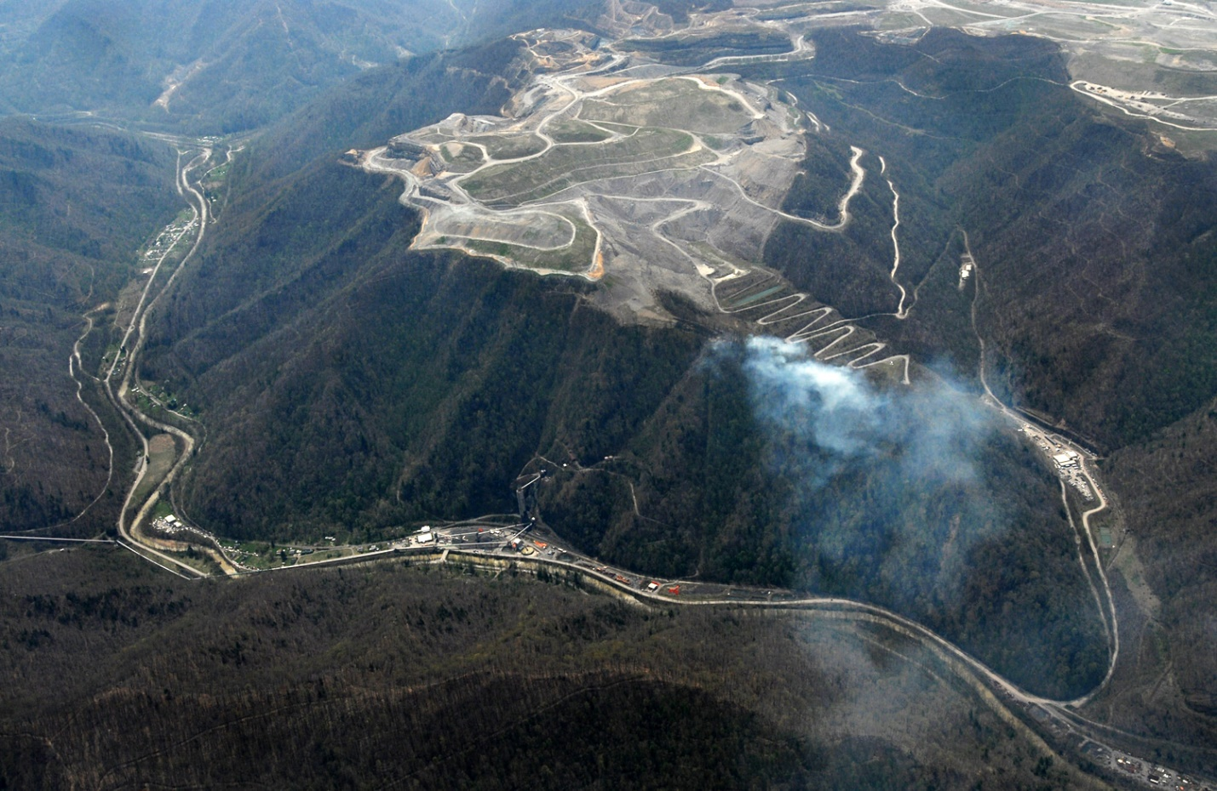

**Team 5:** Alpha Diallo, Bowen Lu, Maksat Mametjumayev, Santiago Corredor

Hult International Business School

BUS 355 - Socially Responsible Business

Dr. Shelley Mitchell

March 1st, 2022

Contents

Executive Summary 3

Situation Analysis 4

Current Situation 4

Stakeholders 4

Relationships 6

Intention 8

Learning Threshold 8

Help 8

Possible Solutions 8

Future Point of View 9

Discussion Questions 11

Question 1 11

Question 2 14

Question 3 15

Question 4 15

Conclusion 16

References 17

# Executive Summary

Placed in the community of Big Branch, West Virginia, at 5:00 pm, a catastrophic line of events that have been piling up for months would reach their conclusion. taking place in the mines owned by the company Massey Energy while in a shift change. These events would lead to a critical failure in several security systems that would lead to an inner explosion of the mine that would end up the lives of 27 of its workers while injuring dozens more, killing later due to the level of their injuries 2 more miners. Being a devastating situation that would finish with the live of 29 of Massey’s workers. Many times, the workers tried to reach out to their managers to address several of the security procedures and problematics that eventually would lead to this catastrophe, and the exact same number of times they were dismissed, sometimes even with smaller threatens such as “*If you can’t go up there and run coal, just bring your [lunch] bucket outside and go home*.” (*The Upper big branch Mine Disaster, 2021 – Page 519)*. Such situations included the lack of ventilations in the mines, required to prevent methanol (a highly inflammable gas with no color or odor) from accumulating in the mines where it has no place to escape. Which combined with the poor state of the equipment, among other reasons, leaded to a spark that would create the tragedy. In the report we are going to analyze the stakeholders involved in the case, the reasons of their actioning and use several tools to understand their thinking and their boundaries for the way they acted. We will then answer several questions regarding the case, given by the textbook and attach our own recommendations to what could have been done better or what could have been avoided so the catastrophe is not repeated in the future.

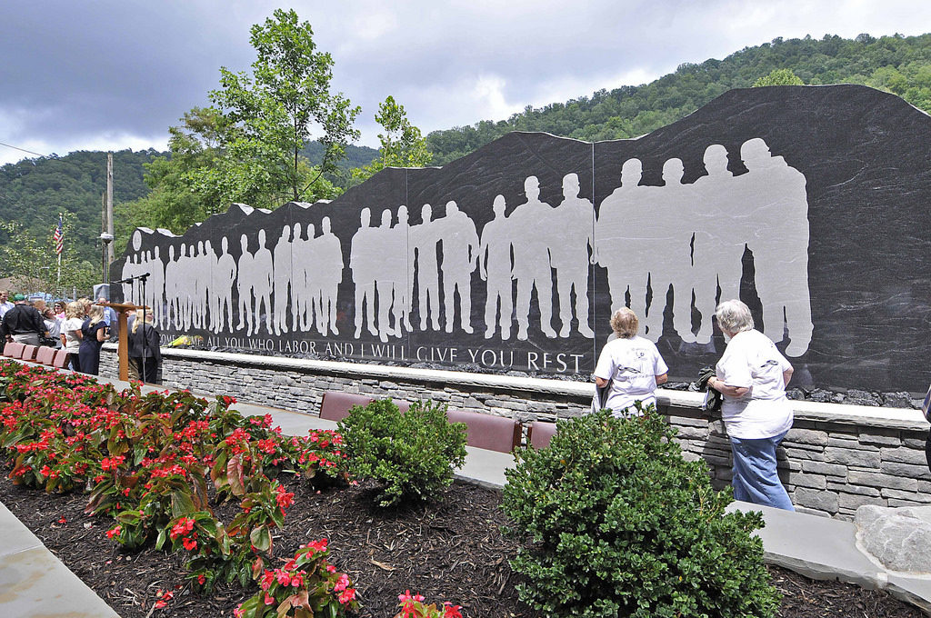

*Fig. 1: Memorial dedication in Whitesville,* Homeland Security Library

# Situation Analysis

## Current Situation

* What key challenge or question is the focal organization up against?

2010 5th of April in Montcoal, West Virginia. The upper big branch mine (UBB in short) owned Massey energy; an explosion killed 29 workers. After the disaster, 3rd parties investigated, and tension rose as the company's report on the event started to conflict with what came out from research of Mine Safety and health organization (MHSA from now on). The focal group chosen for this report is Massey energy, which owned 1/3 of the U.S coal reserve at the time of the event and accounted for 1/2 of the nation's power production. The company is known for suppressing unions with armed guards and none-unionized workers against strikes. And since the disaster would take multiple and lasting systematical failure of the mine's supposedly in the place safety system, it is also concerning how the mine has maintained operation over the years massy energy purchased the mine.

The other core issue massy faced was the safety of production, as quoted “At UBB, of the 23 sprays on the head drum visible to investigators, nine were plugged; of the 30 sprays on the tail drum visible to investigators, seven were totally missing."(*Upper big branch - NPR* page 78). Which, as a side note, removing the spray nozzle is one temporary way to keep the water flowing at the cost of the ability to do the fine spray. And the amount of rock dust has made the explosion five times larger than it would be if it were just methane gas.

We decided to create a SWOT analysis to understand this situation better.

|  |  |
| --- | --- |
| **SWOT Analysis of Upper Big Branch** | |
| **Strengths** | **Weaknesses** |
| ·         Providing jobs  ·         Becoming one of the leading coal producers in the U.S.A.  ·         Specialization in the production of high-grade metallurgical coal.  ·         Increase in production | ·         Violation  ·         Pollution  ·         Dangerous workplaces for miners |
| **Opportunities** | **Threats** |
| ·         Increase in revenues  ·         Export to more foreign countries | ·         Economic changes  ·         Legal issues  ·         Natural disasters  ·         Media |

## Stakeholders

* Who are the relevant stakeholders? How might they view this situation? What are their needs? Include a stakeholder chart of Internal/External and Market/Non-market

Analyzing the case, our team identified the eight major stakeholders who were involved in the Upper Big Branch Mine Disaster. Noticeably, all these stakeholders viewed this situation as an adverse effect and serious tragedy in human life, especially among the U.S. nations. Furthermore, different stakeholders have different needs. For example, one of the main stakeholders is coal miners who mostly prefer to work in safe and healthy workplaces while shareholders might prefer the safe stock market. Based on case analysis, we created Massey Energy Corporation’s stakeholder chart of market or nonmarket, internal, or external.

|  |  |  |
| --- | --- | --- |
| Massey Energy Corporation’s Stakeholder Chart | | |
| **Internal** | Market | Nonmarket |
| Donald L. Blankenship  Coal Miners  Managers |  |
| **External** | Shareholder | Local Community  Governmental Regulators  Environment Organizations  Investigators by United Mine Workers. |

*Fig 2.* Stakeholder Chart

After identifying stakeholders, our team discovered that stakeholders are interested in solutions to three primary issues that jeopardize a company’s sustainability. Firstly, the coal mining occupation considers a life risky because miners need to work in places where is a thread of collapsing roofs and walls as well as working with dangerous mechanical equipment. Additionally, there is a high possibility that miners can develop pneumoconiosis-known as black lung, a chronic and irreversible disease caused by breathing coal dust. Secondly, Massey Energy corporation was one of the primary experts in mountaintop removal mining which brought frequent dumps into neighboring valleys, polluting streams, harming wildlife, and contaminating drinking water. Lastly, exhibit C in the case demonstrates the penalty violation. To be specific, between 2006 and 2009 the company gradually lessened the amount of payment for assessed penalties to the Upper Big Branch Mine. Hence, we are convinced that stakeholders’ interest will go to the solution of these major issues in the company such as establishing a safe workplace for coal miners, preventing pollution, and accepting violation penalties properly.

  According to the third part of the stakeholder analysis, there are five stakeholder powers. These powers were used in various ways in situations at Massey Energy company. For instance:

* **Voting power.** In many workplaces,Workers of the coal industry have voting power to elect safety representatives and locations.  However, coal miners of Massey Energy Corporation were not able to use this power as managers were threading them. In other words, they were claiming that they can lose their jobs
* **Economic Power.**  The Board of Directors of Massey Energy Company used economic power to establish the Incentive Compensation Plan for Massey Energy’s CEO in 2009.
* **Legal Power.**  In response to mining disasters, governmental regulators used their legal power to strengthen their control by establishing regulations for mining companies and monitoring them.
* **Political Power.** One of the government regulators, the Mine Safety and Health Administration (MSHA) has the political power to require at least four full inspections of underground mines annually in mining industries. This refers to the Mine Act which was established in 1977.
* **Information Power.** There were two sets of books at Upper Big Branch, one for the company’s own record keeping while the other is to show inspectors. MSHA claims that the company can keep as many books as the company book, but they have to record the hazards in the official set of books. This emphasizes that managers needed to use their informational power to record sudden methane spikes, inoperative safety equipment, and other dangers in the official set of the book which the inspector’s view. However, managers who did not follow this requirement demonstrate ineffective ways of informational power.

The final aspect of stakeholders’ analysis is stakeholder coalition. Many stakeholders in Upper Big Branch coalition with each other. The case emphasizes the coalition with managers with the CEO, Mr. Blankenship. In other words, every half hour managers were required to fax production figures to Mr. Blankenship, and they directly connected to him via red phones.  Another example of the coalition is governmental regulators with investigators, specifically in response to mining disasters governmental regulators establish and strengthen regulatory control while inspectors/investigators monitor it.

## Relationships

* Based on the information you have - draft a stakeholder map of this case. What sources of power and influence do the relevant stakeholders have?

By examining the stakeholder level of interest and level of power, our team created a stakeholder map. Based on the level of stakeholder’s power and interest, the map is divided into four categories:

1.**Keep satisfied (high power and low interest):** Massey Energy Corporation needs toput enough work in with the group of stakeholders to keep them satisfied.

**2.Manage closely (high power and high interest)**: The managers of the company must engage fully with and make the greatest effort to satisfy stakeholders who are under or close to this category.

3.**Monitor (low power and low interest):**  Monitor stakeholder who is close to this category.

4.**Keep informed (high interest and low power**): Managers need to keep stakeholders in this category adequately informed before major issues are appears

*Fig. 3: Stakeholder Map*

According to the map, four stakeholders were assigned to the “manage closely” category while one stakeholder was put between two categories- “keep satisfied” and “manage closely”. Managers were closely placed in the “manage closely” category. The “keep informed” category includes only environmental organizations whereas local communities were positioned in the middle of the “monitor” category and “keep informed” category. All in all, the map and stakeholder analysis facilitated our team to gain a better understanding of the role and positions of Massey Energy Corporations’ stakeholders in the Upper Big Branch Mine Disaster.

## Intention

* What optimal future scenario is trying to be created by the different stakeholders? Include your team’s recommendations

The investigation of the event was as solid as it could get as it’s the worst incident the U.S had in mining accidents in 40 years, But it can be very different in views of Massy Energy CEO Don Blankenship, as he openly declared and as quote: "if any of you have been asked by your group presidents, your supervisors, engineers or anyone else to do anything other than run coal (i.e. build overcasts, do construction jobs, or whatever) you need to ignore them and run coal," the company is a laser focus on running(producing) coal. Such attitude can also be seen on one of the(company's) reports on the event and quote: "...second, although an ignition source may never be determined, the explosion likely originated in the Tailgate 21 entries, but certainly not as a result of faulty shearer maintenance; " when 16 out of the 53 total spraying nozzles installed on the machine in question has failed of its purpose.

On the other hand, Miners talked about the "alarm system" practices to notify underground managers to avoid safety checks in the investigation. Or avoid the record by running two books and writing off workers' injuries. The investigator seems to hold a relatively neutral stand within the situation, reporting exactly what was found, but the fact, in fact, contradicts every point made in Massy energy's research. The stakeholder groups have their interest when conducting research or the activity. Still, as it stands, the event has resulted in 29 dead, and many came out of the mine with black lounges.

## Learning Threshold

* What are the competing forces - is there space for compromise?

It is hard to pinpoint exactly what might be the likeliest direction to be followed. However, it is important to analyze what took place leading up to the Upper Big Branch mining disaster that took 29 lives at the time. A direction the company would have to choose could have a primary focus on safety for workers in the workplace. The emphasis on workplace safety cannot be stressed enough. To avoid future disasters, and remain in competition, the company would have to enforce safety measures in the mining fields as well as reduce damage done to the local environment (wildlife, streams, potable water). Peabody Coal being mentioned as a solid competitor, with remarkably less accidents is sure to cause a dent to Massey Energy if nothing is done. A merge of both companies could also prove useful in the near future to minimize fatalities and damage to the environment.

## Help

* Where do stakeholders need input or help? Include your team’s recommendations

This section will discuss recommendations that can be made to improve not only the general situation of stakeholders across the board, but also analyze which of their interests are being mismatched. First and foremost, the analysis concluded that one of the major stakeholders whom interests were affected, were the employees, more specifically, the miners. Essentially, they gave their lives for the company whilst working in an uncontrolled and unsafe environment, that we consider could have been avoided. As a means of working efficiently and effectively whilst simultaneously having a better channel of communication to their superior, these workers require immensely improved working conditions. Hence, it becomes evident that the employees or mine workers, as stakeholders, require a large amount of input to improve these live-threatening working conditions, to prevent further catastrophic results.

## Possible Solutions

* What possible solutions might emerge from dialogue between the focal organization and its stakeholders?  Are there natural stakeholder networks that can emerge

Massey Energy is a giant corporation, as such, there are a variety of stakeholders with different needs and goals. Although that may be the case, most decision makers within the company seem to be driven primarily by profit alone. To create a leeway within which the stakeholders and the organization would benefit from, it is crucial to establish a safer work environment. The rate of accidents at Massey Energy’s coal mining company is 1 fatality per 18 million tons of coal mined which is about 16 times more than that of its main competitor Peabody coal. So, to say that it is necessary to implement much better safety measures would be an understatement, as those fatalities affect the local community, more specifically the family of those lost. An opportunity for a new network to emerge would be for Massey to hire the local community through water decontamination firms, creating even more jobs while reducing pollution. A win-win situation for both sides. This way, Massey can ensure better public image while maintaining a relatively stable income stream.

## Future Point of View

* From a future point of view (20+ years): look back on this case, what is your collective highest future possibility?

As a means of analyzing the subsequent success of implemented change, one must allow for some time to pass for said change to take place. With regards to this case, one can consider a viewpoint based on the perspective of the year 2030, which is essentially 20 years after the disaster of 2010.

With regards to this case, it must be noted that equipment of this sort was already in use to improve the overall security of the mines. However, as a means of improving the effectiveness of this measure, we believe that most, if not all employees should undergo further training to operate this equipment. This, will hence increase the use of this technology, thus making the extraction of such essential resources to society more productive and efficient, essentially allowing for an increase in productivity and profit of the company. Optimism can also be seen in the adaptation of this change in companies that may find initial resistance to the regulations imposed by the government, as becomes evident in the already improving safety within companies of this kind, leading to a reduction of people suffering catastrophic accidents from 300 to 400 yearly in the 20th century to less than 50 a year in the 1980s.

As of today, we must consider that society has advanced immensely in terms of artificial intelligence and machine learning in the last decades. Which, connected with several advancements in our engineering capabilities, have opened the possibility of many doors to save hundreds, if not thousands, of human lives by performing certain tasks that can be considered too dangerous and threatening for human life. For instance, one can consider cases such as where rescuing teams need to aid in circumstances in which human life is trapped under the destructive power of a natural disaster, leading to houses burying people alive, waiting to be rescued. Nowadays, instead of additionally risking the life of such rescuing teams, electronic devices can be used for the recognition and removal of these incredibly heavy structures, essentially saving life, without putting any further in danger. Whilst, of course, this process is yet far from perfect, as there are still certain situations requiring human resources, the overall risk in most scenarios has been reduced immensely.

In addition to this, there is also an immense necessity in part of the miners uniting to create more unions demanding improved safety conditions, considering that only less than 1% of miners within this case were part of a union, allowing for only minimal power of taking actions against the company to improve working conditions. Thus, allowing for a greater percentage of workers joining said unions means that scenarios of this kind can no longer be overlooked by either managers or further authorities, as workers will have greater power to voice their concerns to effectively preventing situations in which small changes and improvements could have prevented the escalation of a catastrophe. Essentially, as this job can be considered extremely high risk, it is recommended by us that more than 70% of miners unite to allow the implementations of further safety measures, as in the end, it is them working in such conditions.

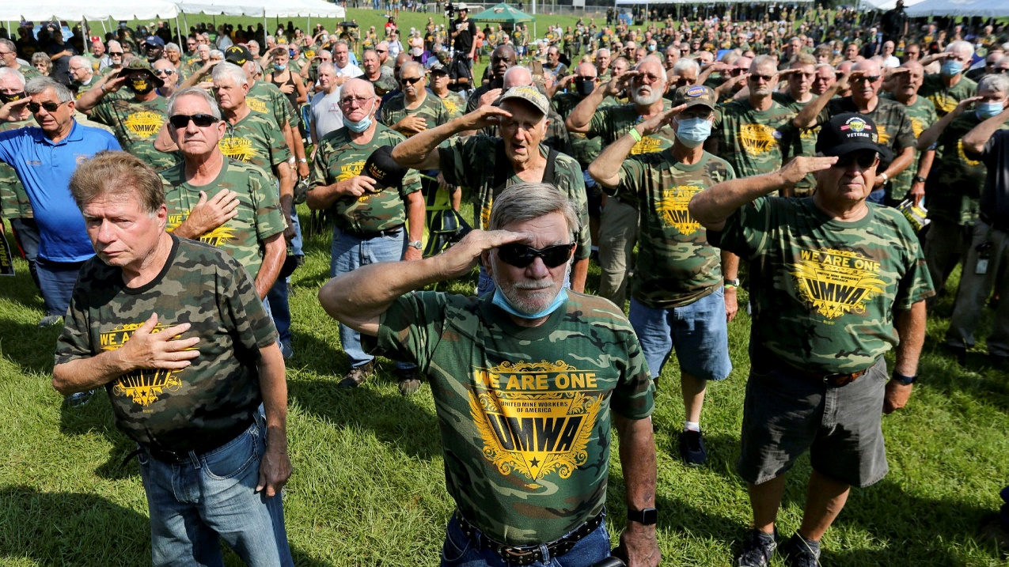

*Fig 4. UMWA Members*

Discussion Questions

## Question 1

1. What were the costs and benefits to stakeholders of the actions taken by Massey Energy and its managers?

Based on evaluation of case, our team established staeoder grid that demonstrates the benefits and risks/costs for them by Massey comp[any

|  |  |  |
| --- | --- | --- |
| **Stakeholder** | **BENEFITS** | **COSTS/RISKS** |
| CEO of Massey Energy Corporation, Donald L. Blankenship | One of the benefits of MR. Blankenship is his *personal gratification.* He was raised by a single mother in a trailer in a Delorme and during his collegiate life, worked in the coal mine to cover his tuition, returned back to Massey Energy as office manager for Rawls subsidiary. He quickly shifted in management ranks and was promoted to CEO and Chairman of Massey Coal Company in1992. Another benefit is *the compensation,* he received by running Massey. To be specific, in 2009, Mr. Blankenship received around $18 million as compensation which is significantly more than total compensation in 2008 and 2007. | Based on the company’s issues that were discussed in the case, there is a high risk for Mr. Blankenship *to damage the personal reputation* that he developed as a hands-on or detail-oriented manager. |
| Coal Miners | In 2009, coal miners gained *job opportunities* as Massey Energy Corporation and its subsidiaries employ 5,800 people in 42 underground and 14 surface mines and several coal processing facilities in West Virginia, Kentucky, and Virginia | The primary risks for coal miners are *death and health issues* as there was one fatality per 18 million tons of coal mined in Massey. Additionally, miners had long been contented with the threat of collapsing roofs and walls, dangerous mechanical equipment, and suffocation. Miners often developed coal workers’ pneumoconiosis, usually known as black lung, a chronic, irreversible disease caused by breathing coal dust. Another risk is *not being able to use freedom of speech* while miners, who were hurt on the job, were told not to report their injuries with the purpose of not recording to NFDL(non-fatal day lost). |
| Managers | *Power* is the benefit that managers gain in Massey as they mostly had the right control, underground miners. | *Work pressure* is the main risk for managers in Massey as they were required to fax production figures to the CEO every half hour, received a call on the red phone when the numbers were incorrect or the report was not sent on time. |
| Shareholders | For shareholders, the benefit is *an increase in the stock market*, for instance, Shareholders who purchased $10,000 worth of Massey stock in December 2004 would have a holding valued at $12,800 in December 2010. | The risk that shareholders should be aware of is a *failure in the stock of Massey* based on the company’s pollution and violation issues. |
| Local Community | As benefits, the local community receives *funding from the company for scholarship programs, partnership with local schools, and emergency support during a natural disaster.* | The risks that the local community takes into consideration are the *company’s pollution and violation issues.* |
| Investigators by UMW | The benefit that goes to an investigator is to *reveal patterns of safety violations* such as finding that the Massey had kept two sets of books at Upper Big Branch, one for its own record-keeping and the other to show inspectors. | Referring to the surviving miner quate, the risk for investigators will be *failing the mission*. He claimed that whenever inspectors write the violation, the lawyers of the company will challenge it in court. |
| Governmental Regulators | One of the benefits for governmental regulators is *supplementary fuel production* as Massey produced the fuel for about half of the electricity generated in the United States, lessening the country’s reliance on imported oil. Another benefit they get is the *power to inspect mines and to fine operators for violation.* For example, the Mine Safety and Health Administration has such power. | The risk for them is *avoidance of violation penalties* by Massey company as it was shown in Exhibit C that the Upper Big Branch Mine started lessening the amount of payment for assessed penalties. |
| Environmental  Organizations | Environmental organizations share similar benefits with the local community- *emergency support during a natural disaster* such as severe flooding in West Virginia. | The primary risk is also like one of the risks for the local community- *pollution*. In other words, the toxic mine sludge which was dropped from an impoundment operated by the Massey in Martin County, Kentucky, polluted hundreds of miles of the Big Sandy and Ohio rivers. |

## Question 2

1. Applying the four methods of ethical reasoning (utilitarianism, rights, justice, and virtue), do you believe Massey Energy behaved in an ethical manner? Why or why not?

From a **Utilitarian** perspective, there are two ways to look at this situation: from Massey Energy’s decisions vis-a-vis the communities, and the latter’s point of view. The endpoint of Massey’s actions led to the disaster on April 5th, which resulted in a big loss for the families of those involved. Massey on the other hand only lost employees that they could replace anytime.

By **Virtue,** if we take on Massey Energy through the value and character of those in charge of the organization, we start noticing a distinct yet consistent pattern. One of greed and carelessness, which ends up costing many lives as a result.

**Justice** being a method of ethical reasoning to show that the equal distribution of gains and losses for this scenario is null and void. Massey Energy simply fails to fall into this category due to many infractions that mostly resulted in them doing more damage to the environment while maximizing profit along the way.

**The Rights** of the people affected in this scenario were not met. Their need for a safer workplace was disregarded. While those in charge of Massey appeared to benefit the most, under Blankenship's direction, minimizing safety equipment costs, resulting in the death of 29 lives.

All in all, through this analysis, Massey Energy company shows major signs of unethicality in multiple fields.

## Question 3

1. Who or what caused the Upper Big Branch mine disaster, and why do you think so?

The ignorance and mentality to focus on the profit of the CEO Don Blankenship and his effort (and pressure) passed through management of the company, combined with the shady dual book operation of the mine led to multiple and consistent failures in the mine's safety feature, not only caused such disaster but also made it as fatal as it is. I.e., the nozzle on the machine was reported to be effectively used less, but it might not be clear in one sentence how bad it is...25% of the water nozzles do not function as designed, that's like missing a tire and still drive.

## Question 4

1. What steps could be taken now to reduce the chances of a similar tragedy occurring in the future? In your answer, please address the appropriate roles of mining companies (and their directors and managers), government regulators and policymakers, and the workers and their union in assuring mine safety.

The role of the Miner Companies, besides making profit (In our perception) is to provide a safe environment for their workers and miners so the company can continue to operate, therefore having a longer space for production of products, increasing their profits in the long term as an added value. We believe one of the major changes that would have been necessary to address to prevent the catastrophic events was to place someone in charge that had the same interest as Blankenship had in the productivity of the company, but in terms of the safety measures required. Having a tough process of selection of the higher ranks, focusing mostly on their perception of the morality involved with the mines, considering is a highly dangerous job on its nature, making it even more important while considering the security implications. In this case targeting a CEO that might understand the work of the field, preferably because of experience by firsthand or in second hand would highly increase its capability to address this security necessity. While Blankenship had this experience and understood the business at his best he was highly focused on the results rather than the actual security of the workers.

In the same way targeting managers that understand the importance of receiving feedback from the miners is the major requirement to decrease, in the future, the chances of these situations happening to the employees. We recommend establishing lines of communication, that are not attached to the higher ranks of the company (such as the CEO), and are connected to other entities such as the Inspectors of the United Mine workers. These problematics can be transmitted to other groups with more power, regardless of the potential grid quest any leader or party can have. Therefore, creating better opportunities for other parties (such as the UMW) to get involved in case of the problematics not being addressed by the company

The last recommendation our team considered was to offer extra benefits to the miners and employees that are part of the labor unions seeking for the fairness and well treatment of their employees. Considering the previous years to the catastrophe, the population that was part of this union that could join and defend themselves in case of finding any irregularities was reduce from 90% in the 1960s to just 19% in 2010, the year of the catastrophe. By being involved in the unions, it is much easier for the employees and miners (in the specific case) to come together a rise their voices in case of need. The results of our report have concluded that while there are several parties that can be blamed for the catastrophic events, they could have been prevented from the beginning if they had the capability to express the problems to the public, creating a problem for the company and forcing them to either take action or be affected by the external environment in the market creating a new necessity to solve any problems that could have been presented by the Union. Being part of these unions provides individual protection to the employees and more resources in case of having to act against any unfair situations. Besides this, there are other benefits of being part of union such as having an increased salary of 27% compared to non-union employees as well as 78% certainty of a pension compared to a 19% of non-union employees. (The Utility Workers Union of America, 2021).

# Conclusion

In conclusion, it becomes evident that there were several factors that leaded to the tragedy that could have been both avoided or addressed if the right stakeholders would have intervened in the right ways. While we can only assume that the previous CEO (Blankenship) was not expecting this line of events to happen, the study concludes that several actions (both by him and other stakeholders) led to what was a time bomb waiting to happen. Giving too much power to one party while not allowing other parties to access this power (like the group of miners) is a mistake, which will lead to not allowing these “weaker” groups to speak and point out certain problems that could be happening and that can be ignored by the stakeholder on command, who/whom might not be as present as the other regarding the situation.

# References

Hillhouse, J. (n.d.). Upper Big Branch Mine Disaster. Homeland Security Digital Library. https://www.hsdl.org/c/tl/upper-big-branch-mine-disaster/

Utility Workers Union of America, AFL-CIO (UWUA). (n.d.). Why Join a Union? Because They Work! UWUA.<https://uwua.net/why-join-a-union/#:%7E:text=Labor%20unions%20give%20workers%20the,higher%20than%20their%20nonunion%20counterparts>

Lawrence, A., & Weber, J. (2016). Business and Society: Stakeholders, Ethics, Public Policy (15th ed.). McGraw Hill.

Tate, C. (2021, April 5). WV Remembers Upper Big Branch Mine Disaster On 11th Anniversary. Ohio Valley ReSource. <https://ohiovalleyresource.org/2021/04/04/wv-remembers-upper-big-branch-mine-disaster-on-11th-anniversary/>

Galuszka, P. (2020, April 10). 10 years after the Upper Big Branch disaster, not much has changed in coal mining safety. Washington Post. <https://www.washingtonpost.com/opinions/local-opinions/10-years-after-the-upper-big-branch-disaster-not-much-has-changed-in-coal-mining-safety/2020/04/09/bd0434f2-7902-11ea-b6ff-597f170df8f8_story.html>

Malo, S. (2021, December 7). Court upholds conviction of ‘king of coal’ over fatal mine blast. Reuters. <https://www.reuters.com/legal/government/court-upholds-conviction-king-coal-over-fatal-mine-blast-2021-12-07/>

Upper Big Branch - Never Again. (2014, April 24). Upper Big Branch - Never Again [Video]. YouTube. <https://www.youtube.com/watch?v=0NYOBEQWIlg>